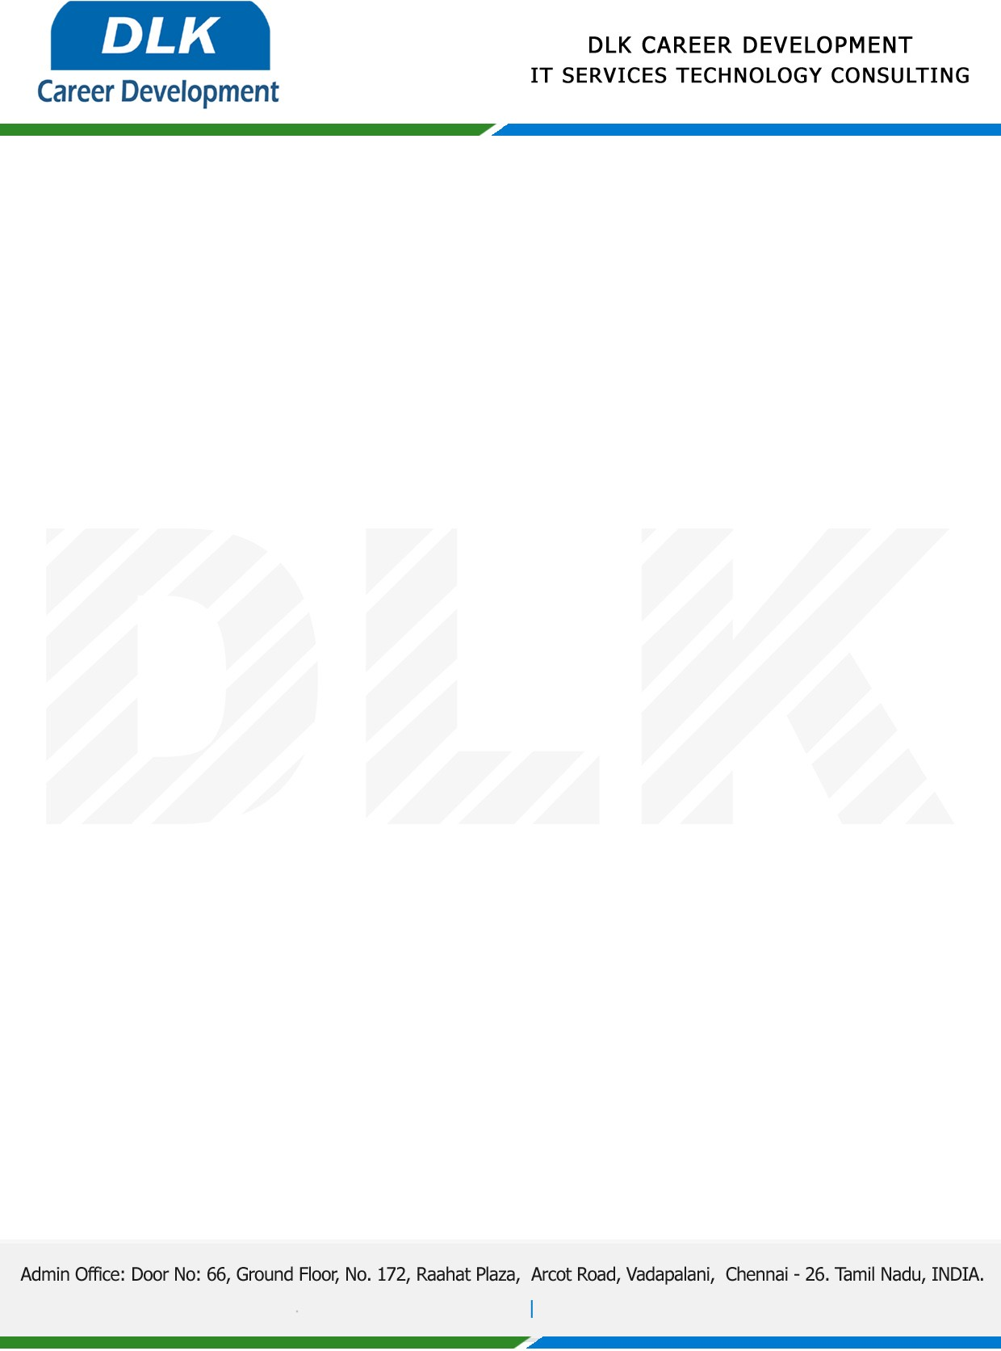

**Date: 27/April/ 2023**

**SUB: PROJECT COMPLETION CERTIFICATE**

This is to certify that **MS MEENAKSHI L G** **(REG NO:** **SP21CPP004)** **MSC- Computer Science,** final year student at **St. Peter's University** has Successfully Completed her Project Work under the domain of “**PYTHON”** in our organization during the Period **(7th November 2022 to 24th March 2023)**

**Topic**: Pharmacy Management System

We appreciate your interest in **DLK CAREER DEVELOPMENT**

**“Best Wishes for Your Future Endeavors “**

